Practice part 1

Act 1 :

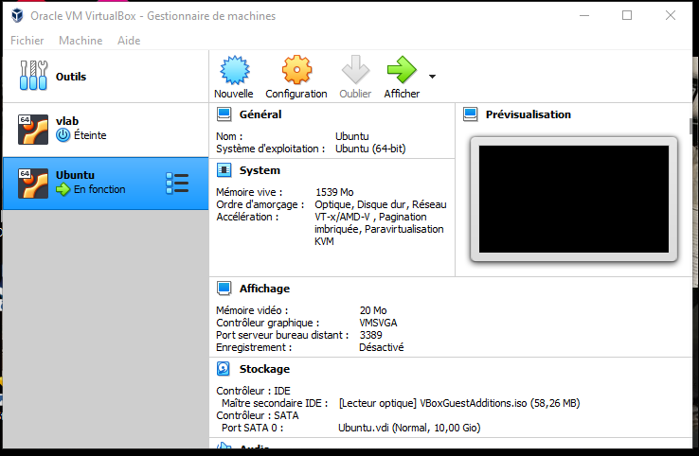

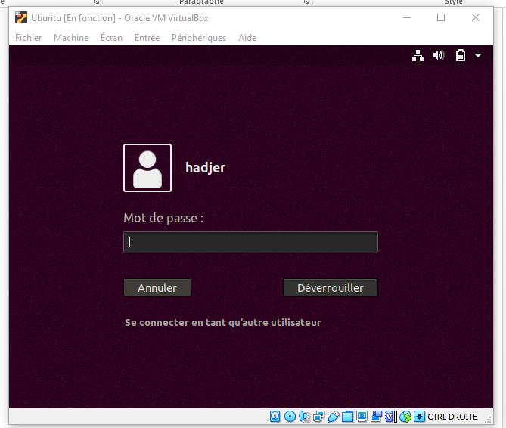

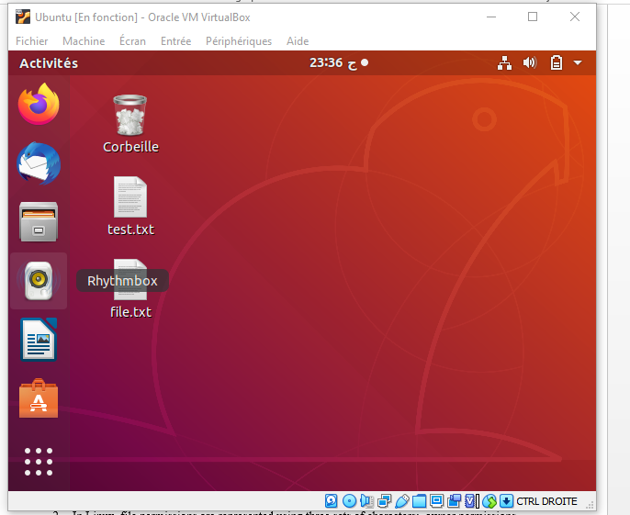

Actevity 2 :

1. Linux uses a combination of MAC and DAC. The DAC aspect involves permissions set by the file owner, while the MAC aspect includes additional access controls set by system administrators.
2. In Linux, file permissions are represented using three sets of characters: owner permissions, group permissions, and others' permissions.

Each set consists of three characters, representing read (r), write (w), and execute (x) permissions.

1. Explain the usage of each command:

* chmod: Changes file permissions.
* chown: Changes file owner.
* chgrp: Changes file group

chmod example :

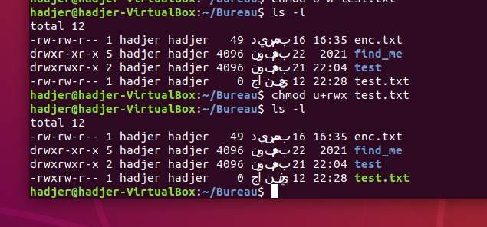

Chgrp example :

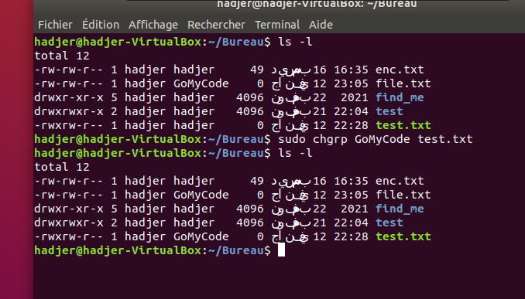

1. /bin contains essential binary executables for all users, while /sbin holds system binaries for system administration tasks. Both directories are crucial for system functionality.
2. 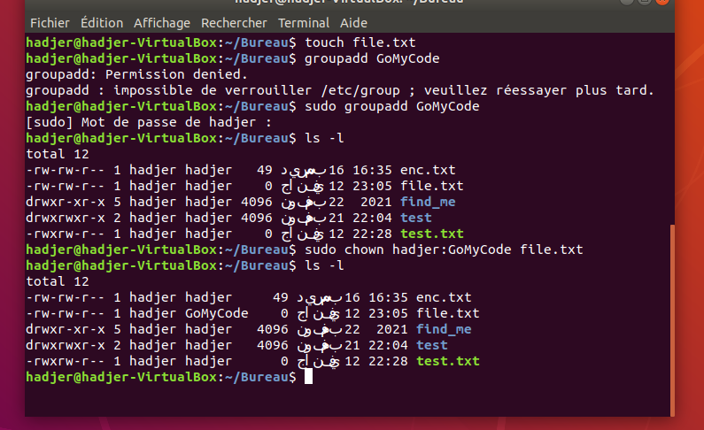
3. rwxr-x-w- is binary : 111101010, octal 752.

rwx--xr-- is binary : 111001100, octal 714.

1. /etc/passwd stores user account information, while /etc/shadow stores encrypted password information. The latter provides an added layer of security by restricting access to password hashes.